**TRAVEL AND TOUR**

**By**

**Shikha Vishwakarma – AF04957**

**Index**

|  |  |  |
| --- | --- | --- |
| **Sr.no** | **Topic** | **Page no** |
| 1 | Title of Project | 1 |
| 2 | Acknowledgement | 3 |
| 3 | Abstract | 4 |
| 4 | Introduction | 5 |
| 5 | Objective | 7 |
| 6 | System Analysis | 9 |
| 7 | System Design | 14 |
| 8 | Implementation & Coding | 23 |
| 9 | Testing | 35 |
| 10 | Result and Discussions | 43 |
| 11 | Conclusion | 55 |
| 12 | Future Scope | 57 |
| 13 | Bibliography | 58 |
| 14 | References | 58 |
| 15 | Tools, and Learning Resources | 59 |

# ACKNOWLEDGEMENT

The project “**Travel And Tour**” is carried out by

|  |  |
| --- | --- |
| **Name** | **Enrollment No.** |
| **Shikha Vishwakarma** | **AF04957625** |

under the Guidance.

We are thankful to my project guide for guiding me to complete the Project. His suggestions and valuable information regarding the formation of the Project Report have provided me a lot of help in completing the Project and its related topics.

We are also thankful to my family member and friends who were always there to provide support and moral boost up.

**Abstract**

Planning a trip can be exciting, but it often gets stressful with so many choices and details to manage. This project, *“Travel and Tour,”* is designed to make that process easier and smarter using Artificial Intelligence. The idea is to create a system that can help users plan their trips by giving personalized suggestions for places to visit, the best travel routes, nearby hotels, and even weather updates — all in one place.

By using AI technologies like chatbots or recommendation systems, the platform can understand what the user is looking for and respond in a helpful and friendly way. Whether someone wants a beach vacation or a quick city tour, the system can guide them based on their preferences and previous choices. It saves time, reduces confusion, and makes travel planning feel less like a task and more like a fun experience.

In the future, this project can be expanded with features like voice support, real-time translation, and even smarter price predictions. Overall, it shows how AI can play a big role in making travel more personalized, efficient, and enjoyable.

# 1.Introduction

Traveling is one of the best ways to explore the world, learn new things, relax, and have fun. Everyone loves to visit new places, try different foods, and experience other cultures. But before enjoying the trip, we all have to face one challenge — planning. Deciding where to go, what to see, where to stay, and how to manage time and budget can be confusing and time-consuming.

These days, people mostly depend on search engines, travel websites, YouTube videos, or blogs to collect information. While these platforms offer a lot of data, they also leave users with more questions than answers. For example, “Which destination suits my budget?”, “What’s the best time to visit this place?”, or “Can I book everything in one place?” The entire process becomes tiring and stressful. This is where Artificial Intelligence (AI) comes in as a smart and helpful travel buddy.

Our project, called “Travel and Tour with AI,” is designed to make travel planning easy, quick, and personalized using the power of AI. Just like how a friend helps us plan a trip, this system acts like a virtual travel assistant. It can:

* Recommend the best destinations based on your interests and budget
* Suggest places to visit and eat at the chosen location
* Help with hotel and transport booking options
* Give real-time weather updates
* And even chat with the user to answer common travel questions

Imagine telling a chatbot, “I want to visit a peaceful hill station in July with my friends,” and it immediately suggests places, hotels, and even travel tips. No need to search ten different websites — the system does the hard work for you!

To make this possible, we use AI technologies like machine learning (to learn user preferences), natural language processing (to understand what users’ type), and recommendation systems (to give smart suggestions). The goal is simple: make the travel experience smooth and stress-free from planning to booking.

This system is helpful for anyone — students planning a trip, families on vacation, or even solo travellers. Whether you're a beginner traveller or a regular explorer, it makes planning feel effortless and fun.

In this report, you will read about how the idea was born, how the system was built, what technologies were used, and how it was tested. You will also see results, future improvements, and what more can be added to make it even better. The aim is to show how AI is not just for big industries but can also become a smart travel guide for everyday users like us.

In simple words, this project brings together technology and tourism to create something truly useful, exciting, and enjoyable.

**2.Objectives**

The scope of this project includes the development of a **travel assistant system** that uses AI to guide users through the process of planning a trip. The system focuses on the following features:

* **Destination Suggestions** based on user preferences (e.g., beach, hill station, adventure)
* **Hotel Recommendations** and availability
* **Real-time Weather Updates** for the selected location
* **Chatbot Assistance** to answer travel-related questions
* **Easy and user-friendly interface**

The project uses technologies such as:

* **Machine Learning** to learn user choices and improve suggestions
* **Natural Language Processing (NLP)** to understand user input
* **Recommendation Systems** to suggest places and hotels
* **API Integration** for weather and maps This system is useful for:
* Students and young travellers
* Families planning vacations
* Solo travellers
* Travel agencies wanting to automate suggestions

In the future, this project can be expanded to include features like:

* **Voice commands**
* **Budget planning**
* **Flight and train booking**

**NOW THE ONE QUESTION IN PEOPLE MIND HOW WE USE THIS AND HOW IT IS EASY:**

What if planning your next dream trip was as simple as chatting with a friend? What if — in just a few clicks — you could get personalized suggestions, book hotels, check weather, and even discover hidden gems in a new city without opening ten different tabs?

In today’s fast-moving world, travel is more than just going from one place to another — it’s about creating experiences. But let’s be honest — planning a trip can often feel like solving a puzzle. Searching for the right destination, looking up hotels, figuring out transport options, reading reviews, comparing prices — all of this takes hours, sometimes days. That excitement we feel at the thought of traveling often gets buried under stress and confusion.

This is where our project, “Travel and Tour with AI,” steps in — not just as a tool, but as your smart travel companion. It is built to help users plan their trips in a simple, smart, and stress-free way using the power of Artificial Intelligence. From understanding your preferences to offering tailor-made suggestions, it works just like a friend who knows exactly what you want from your journey.

So, instead of saying *“I don’t know where to start,”* imagine saying *“Show me peaceful places for a weekend getaway,”* and the system instantly offers you the perfect spots, best hotels, estimated costs, and even weather forecasts — all in one place.

Using technologies like machine learning, chatbots, and recommendation engines, this project brings together travel and tech to create something truly helpful and humanlike. It's not just another app — it’s a new way to explore the world.

This report takes you through the journey of building this AI-based travel assistant. You'll discover how it works, the tech behind it, the challenges faced, and how it aims to change the way we travel. By the end of this black book, you might not just understand the project — you might actually want to use it.

So, keep reading — this isn’t just a project, it’s the beginning of smarter, easier, and

more exciting adventures.

**3.System Analysis**

**3.1 Existing System**

The current system used by many travel agencies is mainly manual and traditional. Here's how it typically works:

* **Booking Process**: Travel agents usually communicate with customers through phone calls, emails, or face-to-face interactions to book flights, accommodations, tours, and other travel-related services. The process involves a lot of back-and-forth communication, which can sometimes be time-consuming and prone to errors.
* **Managing Itineraries:** Agents use spreadsheets, paper forms, or other basic tools to track and manage customers' travel itineraries. These itineraries may include flight details, hotel bookings, tours, and other activities. However, managing this data manually can lead to mistakes and inefficiencies, especially when dealing with multiple clients at once.
* **Customer Support**: For customer support, travel agencies often rely on traditional methods like phone calls or emails. This means customers have to wait for responses, and it's challenging to provide instant support at all times.
* **Limited Data Integration**: The current system does not integrate real-time data sources. For example, it may not provide live updates on things like flight delays, weather conditions, or traffic. This lack of integration can result in a poor experience for customers, especially if they are unaware of delays or disruptions affecting their trips.
* **Personalization Issues**: Travel agencies may not have the tools to offer personalized recommendations to customers based on their preferences, past trips, or browsing habits. This means customers might not get suggestions that are tailored to their tastes, which could affect their satisfaction with the trip planning process.

**3.2 Proposed System**

The proposed system aims to modernize and improve the travel booking process by integrating Artificial Intelligence (AI), which will automate many of the tasks that are currently done manually. Here's a deeper look at the key features of the new system:

* **AI-powered Chatbots**: One of the major improvements is the use of AI-powered chatbots that will be available 24/7 to assist customers. These chatbots can answer questions, provide travel suggestions, help with bookings, and even troubleshoot problems. The chatbot will allow customers to get immediate answers without waiting for a human agent. This will be especially helpful for customers in different time zones or for those who need help outside of business hours.

* **Personalized Itinerary Recommendations**: The AI will have the ability to learn from each customer's preferences. For example, it can suggest destinations, activities, or restaurants based on the customer’s previous trips, interests, and other personal factors. The system could even recommend specific travel packages tailored to the user’s budget, lifestyle, and preferences, which will make the booking experience more relevant and enjoyable.

* **Predictive Analytics for Demand and Pricing:** The new system will use predictive analytics to forecast demand for travel during specific times of the year (like holidays, summer breaks, or long weekends). Based on this demand prediction, the system can adjust prices to optimize for higher or lower demand, ensuring businesses make the most of peak seasons while offering fair pricing during offpeak times.

* **Real-Time Updates:** The system will be able to provide customers with real-time updates about their travel plans. This could include notifications about flight delays, weather conditions at their destination, changes in their travel itinerary, or updates on traffic conditions. This feature will allow customers to stay informed at all times, reducing stress and improving the overall travel experience.

**3.3 Requirement Analysis**

In this step, we need to clearly define what the system must be able to do. This is broken down into three types of requirements:

* **User Requirements:** The system must allow customers to book trips easily in real-time, without delays or complications. It should also offer personalized recommendations based on their individual preferences. Customers should be able to easily access their travel itineraries from any device, whether it's a mobile phone, tablet, or computer. The interface should be simple, intuitive, and userfriendly, so customers can navigate through the process without confusion.

* **Business Requirements**: For businesses, the system must be able to handle large numbers of users simultaneously, especially during peak travel seasons. The system should be able to automate customer support, meaning that travel agents don't have to answer every question individually. Additionally, the system should help businesses optimize resource allocation, such as efficiently managing booking schedules, staff, and equipment.

* **Technical Requirements:** Technically, the system will need to integrate with databases to store large amounts of customer data, transaction records, and itineraries. It will also need to use AI algorithms for tasks like demand prediction, personalization, and real-time updates. The system should be mobile-friendly, as many customers prefer to use their phones to plan and manage their trips. It must also be built with security measures to protect sensitive customer data and comply with privacy regulations.

**3.4 Hardware Requirements**

To make the system work efficiently, we’ll need some specific hardware:

* **Servers for Data Processing:** The system will need servers to store large amounts of data, such as customer details, booking information, and AI-generated recommendations. These servers should be cloud-based, meaning they are hosted on the internet and can scale up or down depending on demand. This ensures the system can handle a growing number of users without performance issues.

* **High-Performance Computing Units**: Running AI models and processing large amounts of data requires powerful computers. The system will need highperformance computing units that can handle complex calculations and predictions, like determining the best travel destinations or forecasting demand trends.

* **Customer Devices:** The system must also be compatible with the devices that customers will use to interact with it, such as smartphones, tablets, and desktop computers. This ensures that customers can access the system no matter where they are or what device they prefer to use.

**3.5 Software Requirements**

The software needed to build the system includes:

* **AI Software Libraries/Frameworks:** To develop and deploy the AI models, we will use software libraries like TensorFlow, PyTorch, or Scikit-learn. These tools help create smart systems that can learn from data and make decisions, such as predicting travel demand or offering personalized suggestions.

* **Backend Development Frameworks:** On the server side, we’ll need frameworks like Node.js, Django, or Flask to handle the backend logic. These frameworks are essential for managing requests from users, interacting with databases, and ensuring the system runs smoothly behind the scenes.
* **Database Management Systems:** We’ll need to store lots of data, including customer profiles, booking details, and transaction histories. This will require SQL or NoSQL databases, depending on the data type. SQL databases are great for structured data, while NoSQL databases can handle unstructured or flexible data.

* **Cloud Infrastructure:** Services like AWS, Google Cloud, or Azure will provide the infrastructure to run the system. These cloud services will allow the system to be scalable, meaning it can handle more users or data as needed. They also offer flexibility and reliability, ensuring the system stays up and running even during high demand.

**3.6 Justification of Selection of Technology**

Now, let's look at why these technologies were chosen:

* **AI Technology:** AI is the key to automating many processes and making the system smarter. By using AI, we can offer personalized travel recommendations, automate customer support, and predict demand to optimize pricing. This helps businesses improve efficiency and increase customer satisfaction, as customers get a tailored experience.

* **Cloud Infrastructure:** Cloud-based solutions are essential because they offer scalability and flexibility. Travel demand can fluctuate, especially during holidays or peak seasons. By using the cloud, the system can easily scale up to handle a larger number of users during busy times. Plus, cloud-based systems provide high availability and data backup, so the system will continue to function smoothly even if there are unexpected issues.

# 4.System Design

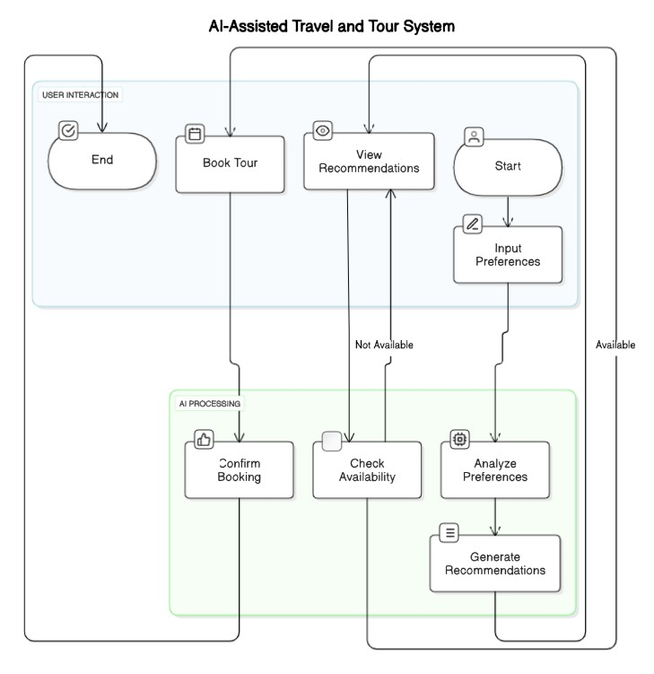

Brief Description of the Diagram:

The diagram illustrates an AI-Assisted Travel and Tour System that integrates user interaction with AI processing to provide a smart and seamless travel booking experience.

* User Interaction Section:

Users begin the process by starting the application and inputting their travel preferences. They can view AI-generated recommendations and proceed to book tours. The process concludes with an end state after booking.

* AI Processing Section:

AI analyses the user’s preferences, generates personalized recommendations, checks the availability of tours, and confirms bookings automatically.

* System Flow:
  + - Users input preferences → AI analyses and generates recommendations. o Recommendations are displayed to the user. o If a preferred tour is available, AI checks and confirms the booking.
    - If not available, the user is prompted to view other recommendations.

This system enhances travel planning by using AI to tailor experiences based on user preferences and real-time data availability.

**4.1 Module Division:**

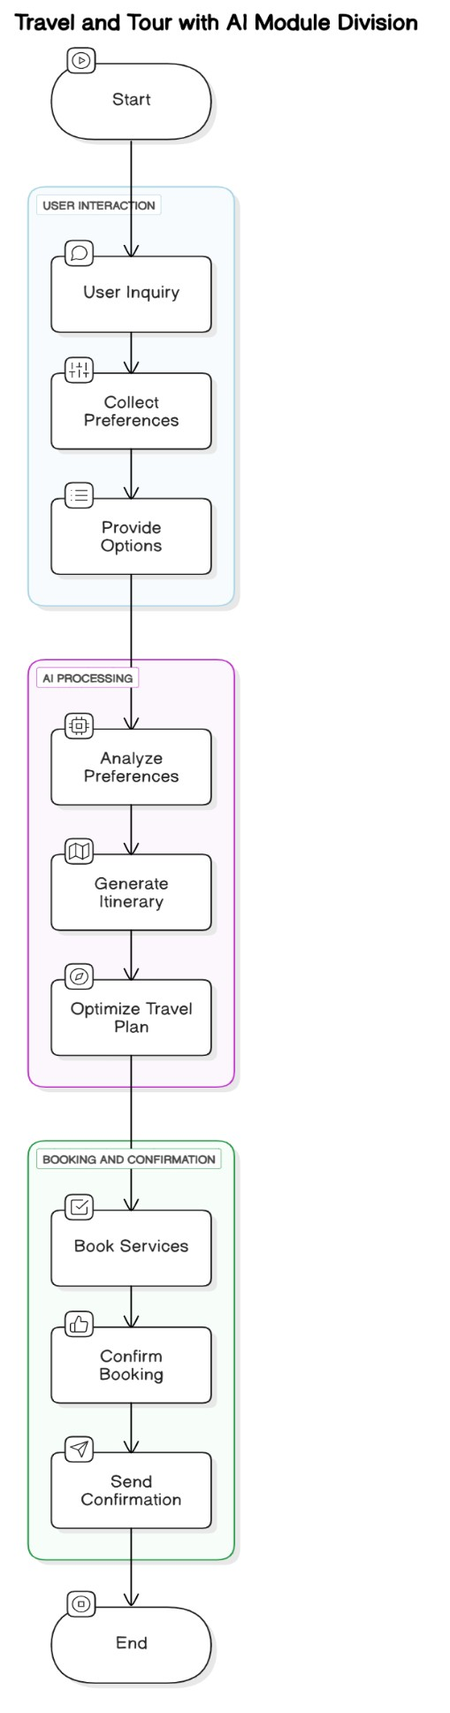This system helps users plan and book trips using AI in three main parts:

1. **User Interaction** o The user asks about travel. o They give their travel preferences (like location, budget, dates).

o The system shows travel options.

1. **AI Processing** o The AI understands the user's preferences. o It creates a travel plan (itinerary).

o Then it improves the plan for the best experience.

1. **Booking and Confirmation**
   * The system books the services (like flights, hotels).
   * It confirms the booking.
   * Then it sends the final details to the user.

The process starts when the user makes a request and ends after they receive the confirmation.

**4.2 Data Dictionary :**

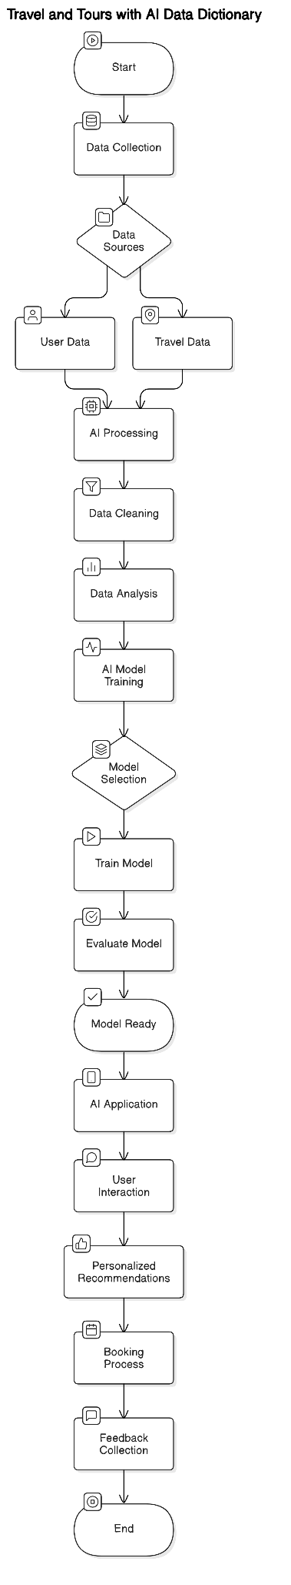This diagram shows the full process of how an AI-based travel and tour system works, step by step:

* + 1. **Start**

o The system begins the process.

* + 1. **Data Collection**

o Collects user and travel-related data.

* + 1. **Data Sources**

o Information comes from two places:

* User Data (preferences, location, etc.)
* Travel Data (flights, hotels, places to visit)

1. **AI Processing**

o The system begins analyzing the data using AI.

1. **Data Cleaning**

o Removes any wrong or extra data to keep things clear.

1. **Data Analysis**

o Studies the data to understand user needs and options.

1. **AI Model Training**

o Teaches the AI how to make smart travel decisions.

1. **Model Selection**

* Picks the best AI model for the job.

1. **Train Model**

o Final training step to make the model ready.

**10.Evaluate Model**

* Tests if the AI is working properly.

**11.Model Ready**

* Confirms the AI is now ready to be used.

**12.AI Application**

* Applies AI to real tasks, like making travel plans.

**13. User Interaction**

• User communicates with the system to get help.

**14. Personalized Recommendations**

• The AI suggests trips based on the user’s likes.

**15. Booking Process**

• Helps the user book flights, hotels, etc.

**16. Feedback Collection**

• After the trip, it asks the user for feedback to improve.

**17. End**

• The process finishes.

**4.3 E-R Diagrams**

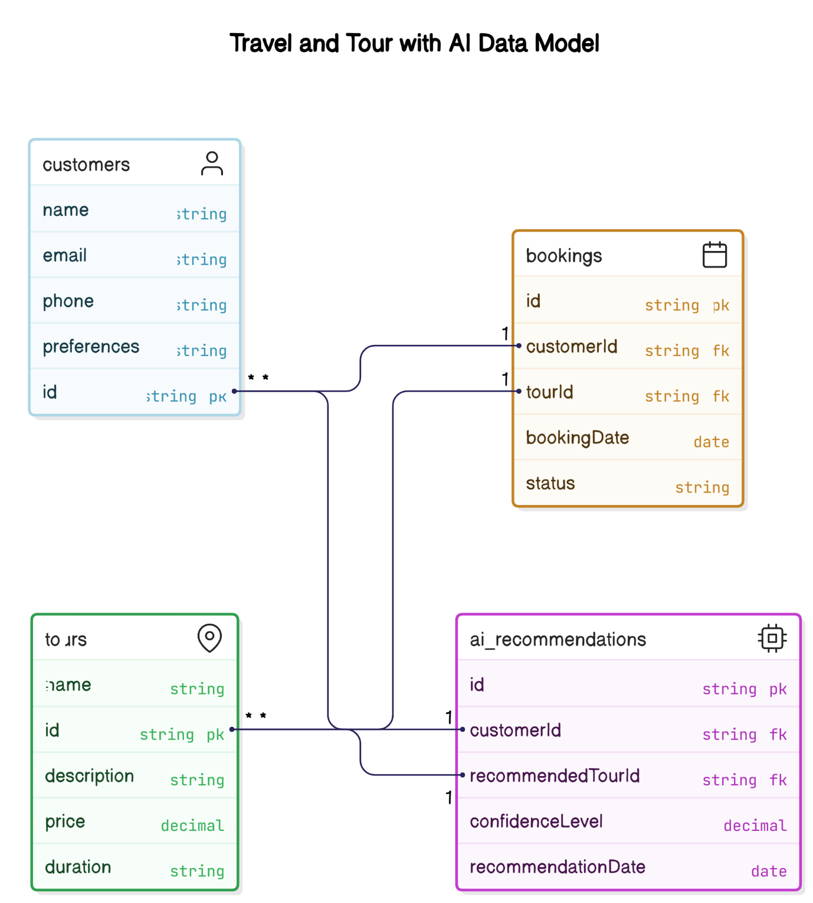

This schema shows how data is structured and connected in the system:

1. **customers** 
   * + Stores information about each user.
     + Fields:

o id: Unique customer ID (Primary Key) o name, email, phone: Contact details o preferences: User travel likes/interests

1. **tours** 
   * + Contains information about available tours.
     + Fields:

o id: Unique tour ID (Primary Key) o name: Tour name o description: Details about the tour o price: Cost of the tour o duration: Length of the tour

1. **bookings** 
   * + Records when a customer books a tour.
     + Fields:

o id: Booking ID (Primary Key) o custom rid: Link to the customer (Foreign Key) o tourID: Link to the tour (Foreign Key) o bookingDate: Date of booking o status: Booking status (e.g., confirmed, cancelled)

1. **Ai recommendations** 
   * + Stores AI-generated suggestions for tours.
     + Fields:

o id: Recommendation ID (Primary Key) o customerId: Link to customer (Foreign Key) o recommendedTourId: Link to the suggested tour (Foreign Key) o confidenceLevel: AI's confidence in the recommendation (as a decimal) o recommendationDate: When the recommendation was made **Relationships:**

* + - One customer can have many bookings and AI recommendations.
    - Each booking and recommendation is linked to a specific tour

**4.4 Data Flow Diagrams / UML**

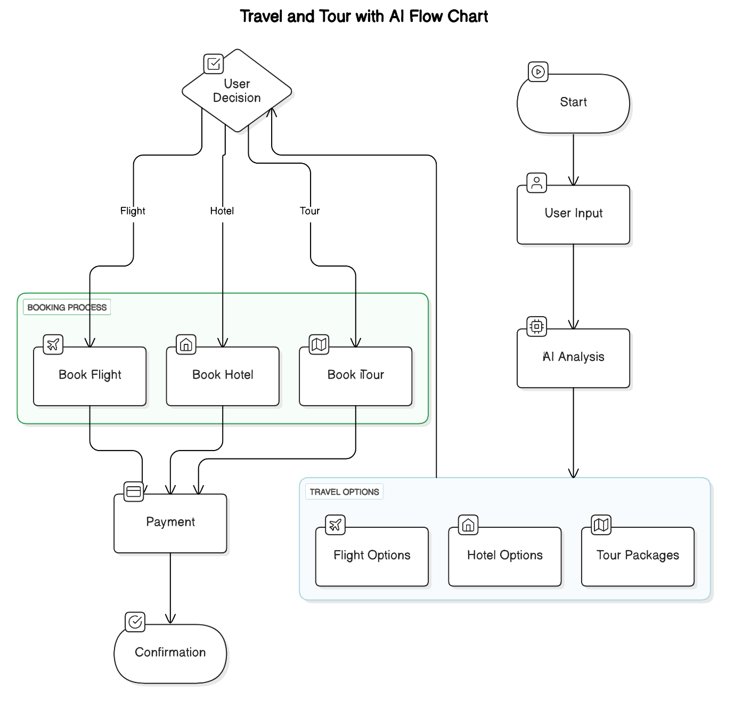

Flowchart – Travel and Tour with AI

This flowchart illustrates the AI-assisted travel booking process:

1. **Start** 
   * The user begins the travel booking process.
2. **User Input** 
   * User provides preferences such as destination, budget, and travel dates.
3. **AI Analysis** 
   * AI analyses user input and behaviour to suggest personalized travel options.

Travel Options

* + Based on the analysis, AI provides:
    - Flight Options o Hotel Options o Tour Packages

1. **User Decision** 
   * The user reviews the AI suggestions and selects the desired travel plan.

Booking Process

* + The system processes the user's choices:
    - Book Flight o Book Hotel o Book Tour

1. **Payment** 
   * User completes the booking through a payment gateway.
2. **Confirmation** 
   * A final confirmation is provided after successful payment.

# 

# 5. Implementation & Coding

The project was developed using the **MERN Stack**, which includes **MongoDB** for the database, **Express.js** for backend API handling, **React.js** for the frontend interface, and **Node.js as** the runtime environment. The AI logic was integrated through APIs and used to analyse user preferences and suggest personalized travel options.

**Frontend (React.js):**

The frontend was built using React.js, which provides a responsive and interactive interface. Key components include:

* Booking Components for Flights, Hotels, and Tours
* Form Components to capture user preferences
* Dashboard & Confirmation Pages to manage and review bookings API calls are made from the frontend to fetch AI recommendations, available travel options, and process user bookings.

**FRONTEND: core segments**

**TourDetail.jsx:**

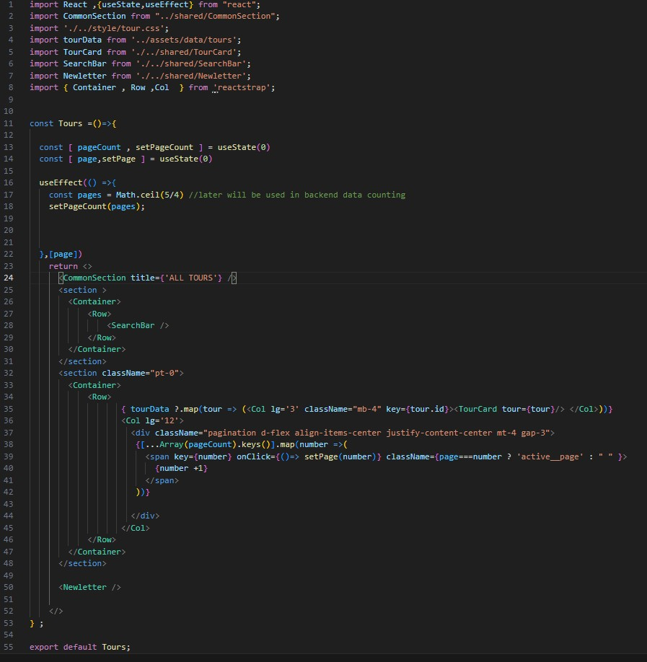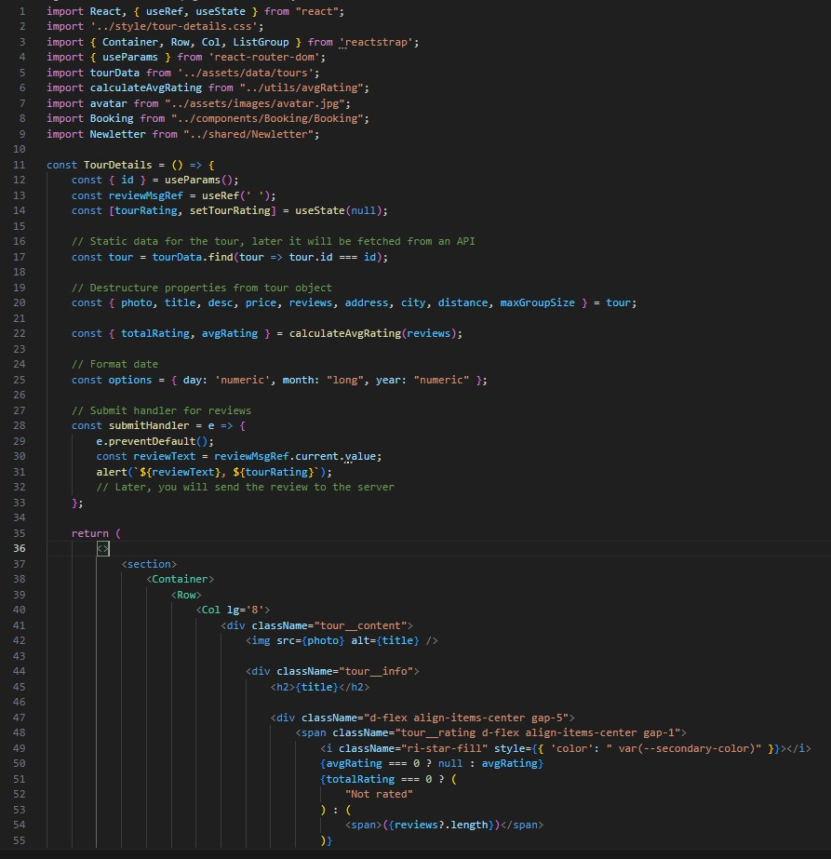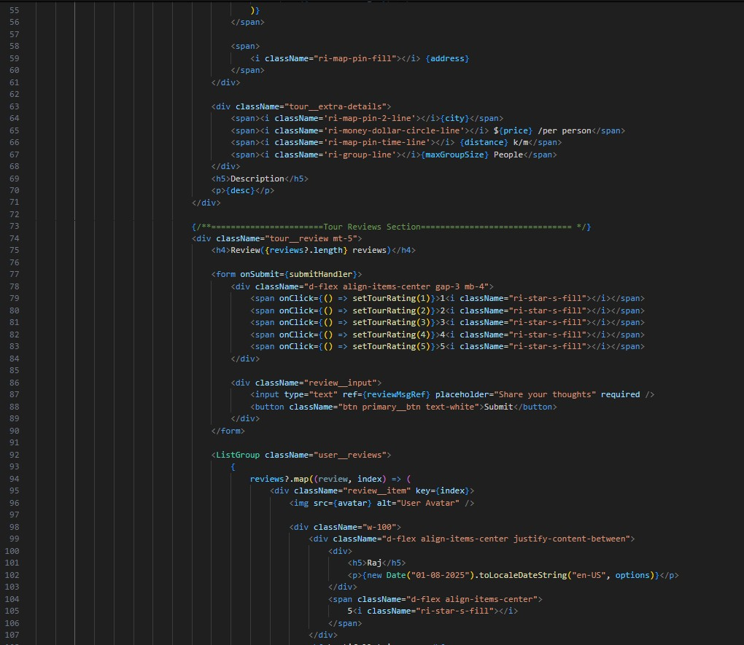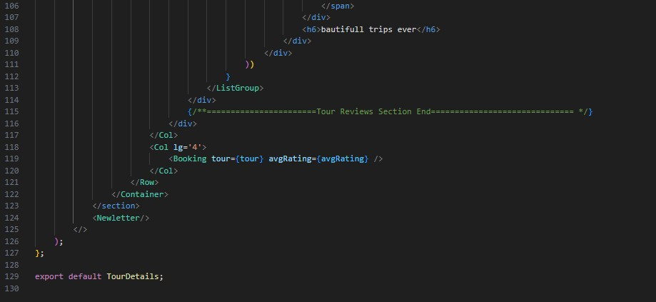

**Home.jsx:**

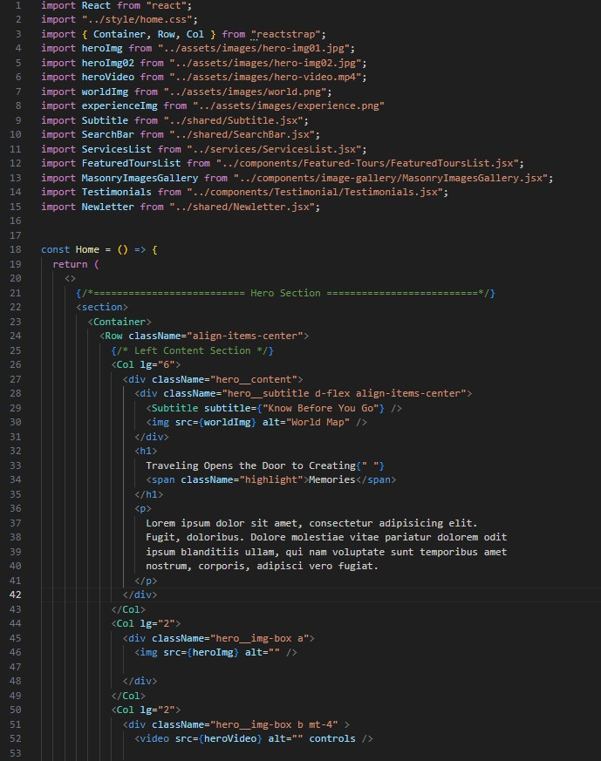

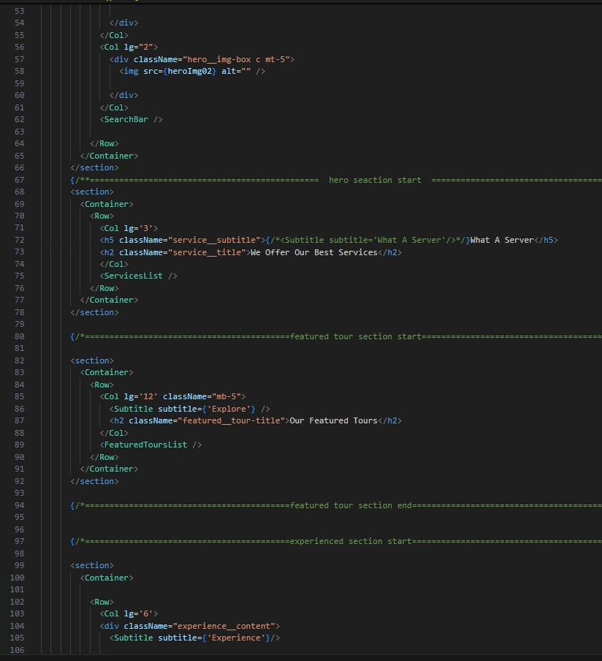

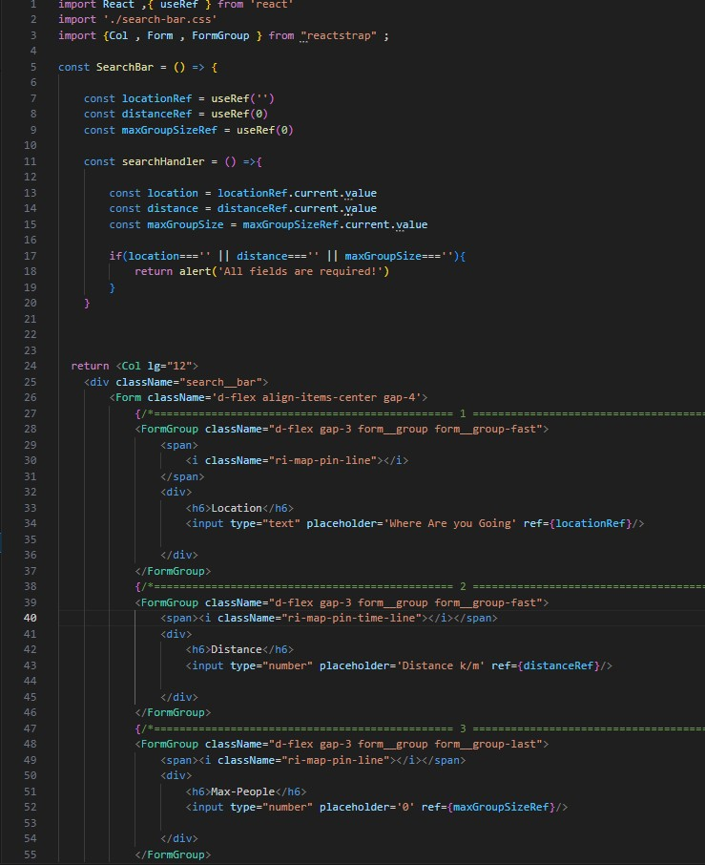

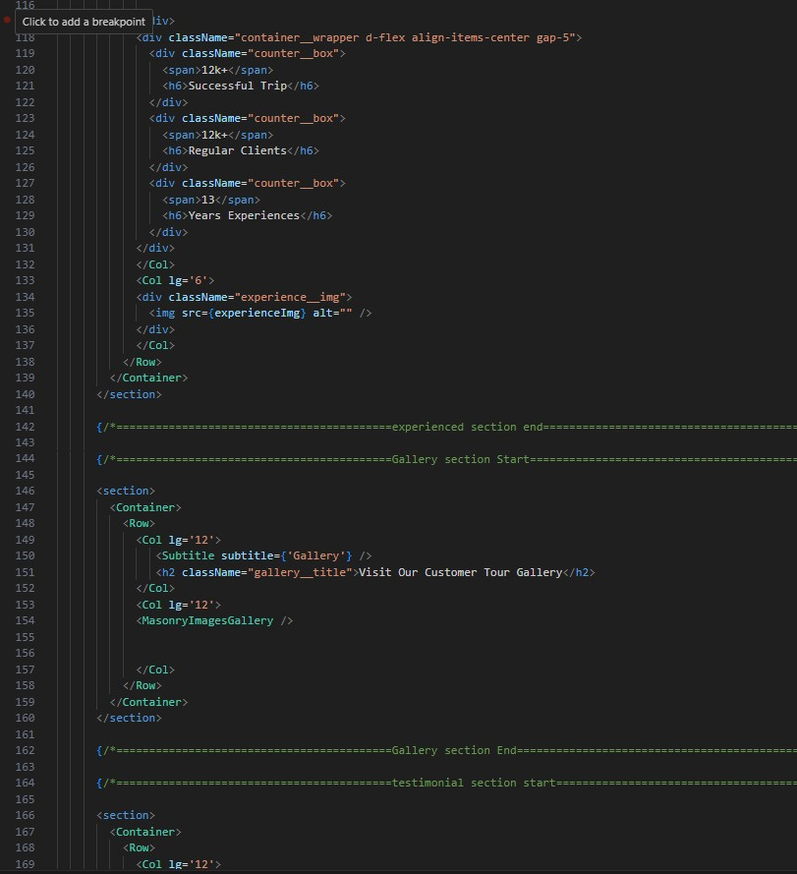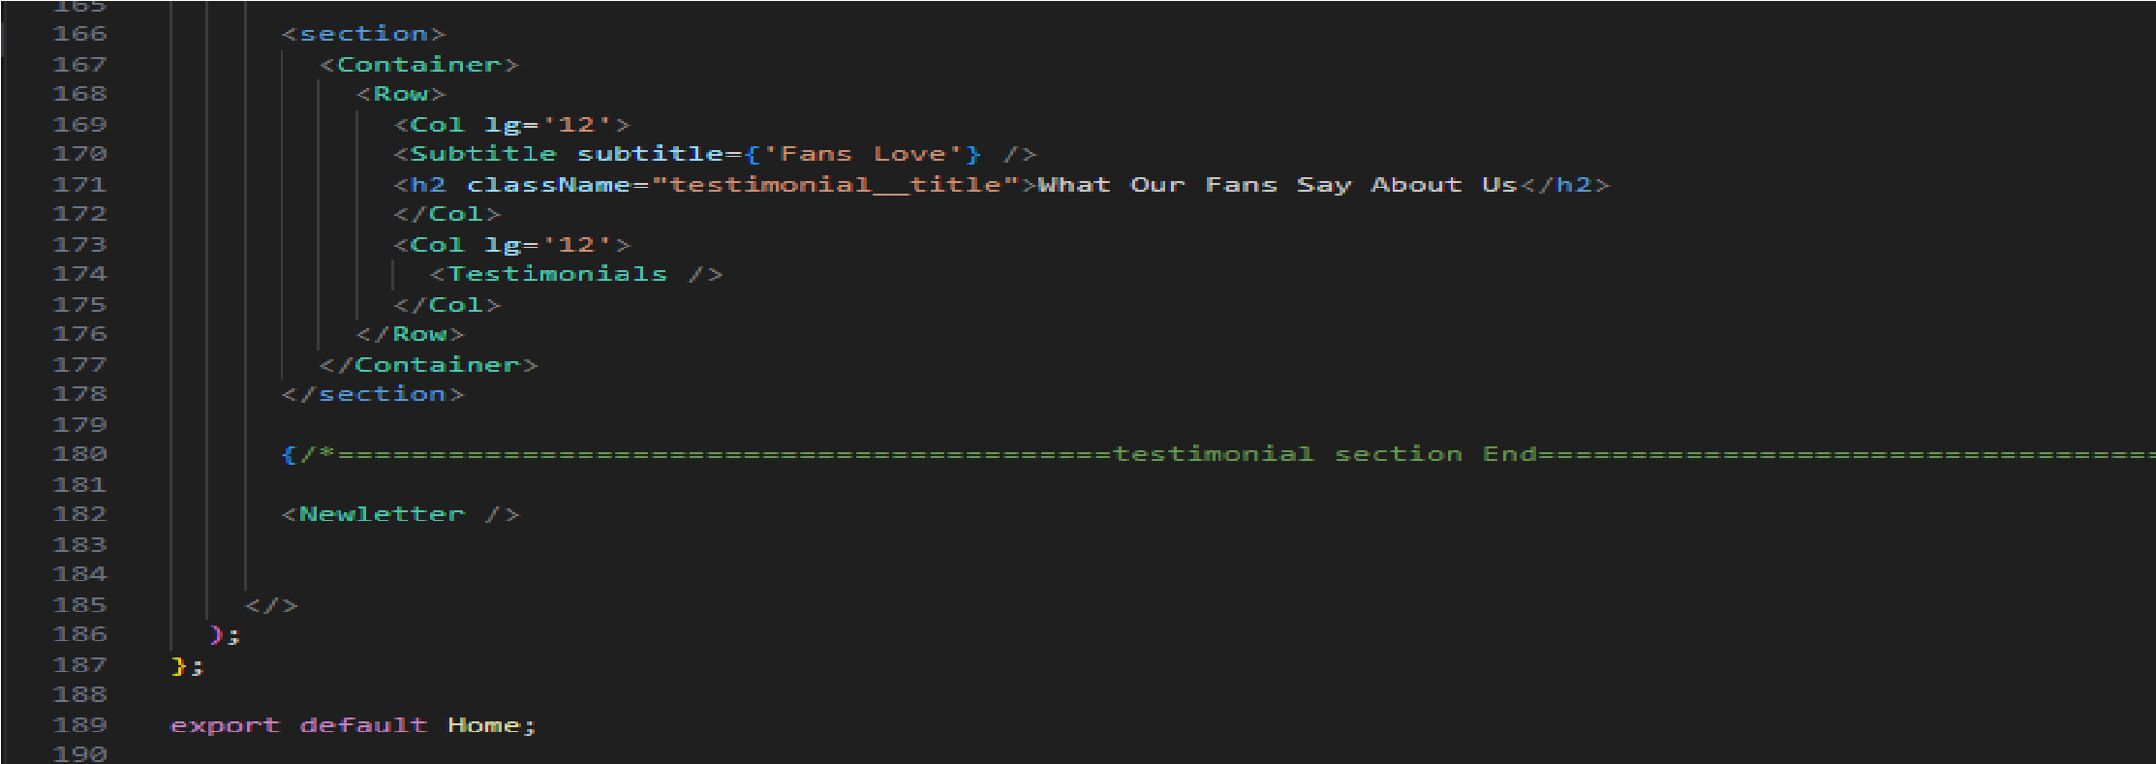

**SearchBar.jsx:**

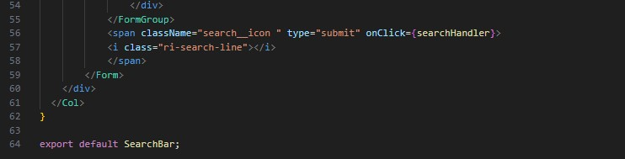

**Backend (Node.js + Express.js):**

The backend uses Node.js and Express.js to create RESTful APIs for:

* User authentication and registration
* Fetching and storing bookings
* Getting AI-generated tour suggestions These routes manage communication between the frontend and database, and also act as a middle layer for AI API integration.

**Database (MongoDB):**

Data such as users, bookings, tours, and recommendations are stored in MongoDB collections. The database structure follows a normalized approach and is designed to link user preferences with available tour data. Mongoose is used to model schemas.

AI Recommendation Integration:

The AI logic receives user input like destination interest, budget, and duration. Based on these, it:

* Analyses travel history (if available)
* Scores each tour package with a confidence level
* Returns top recommendations via API to the frontend This AI module is either a separate service or built within the Node backend, depending on complexity

**Index.js**

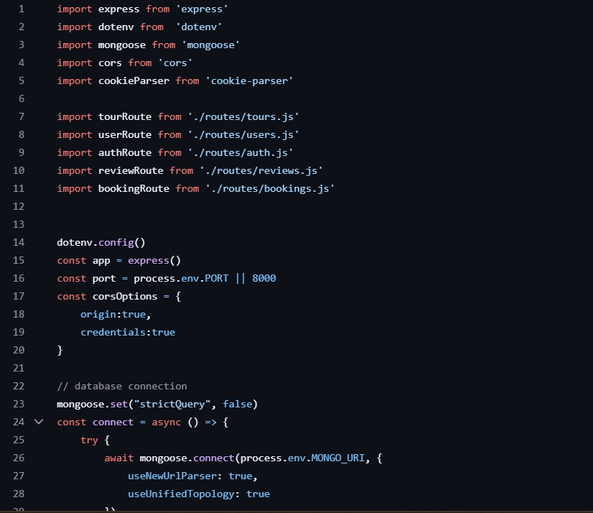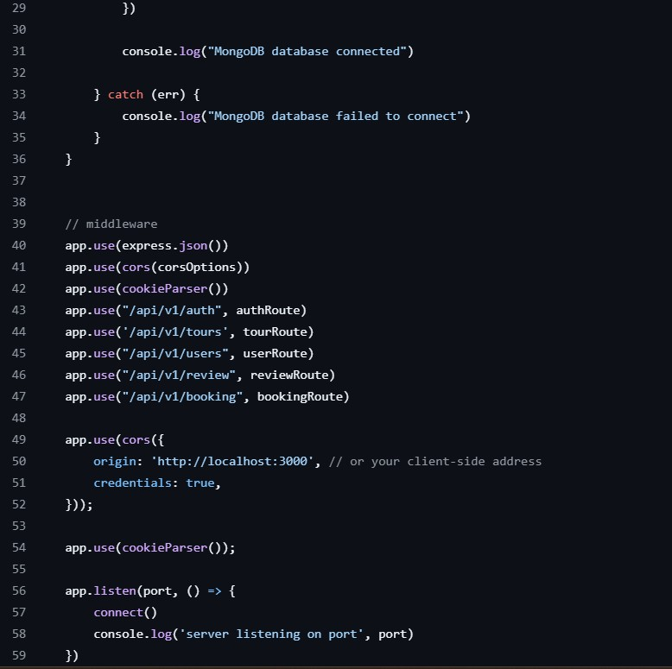

**Env.**

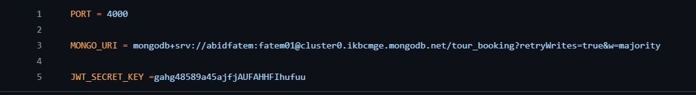

**User.js**

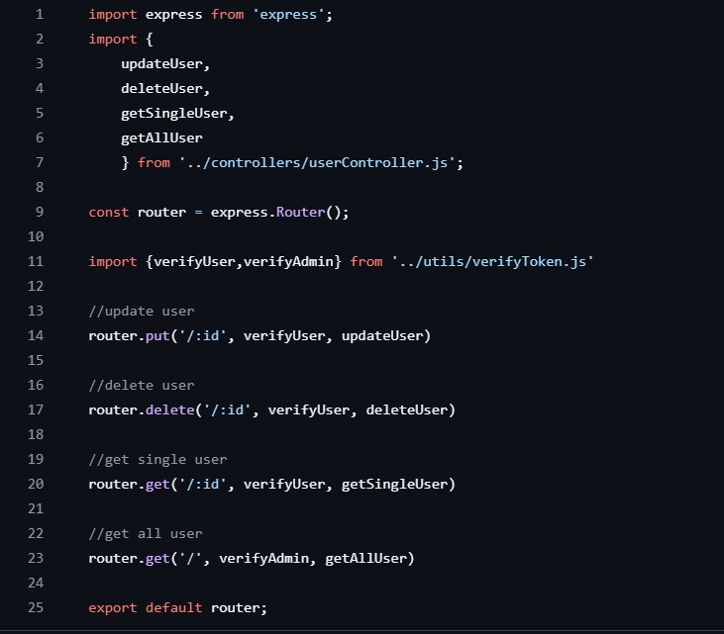

**Tour.js**

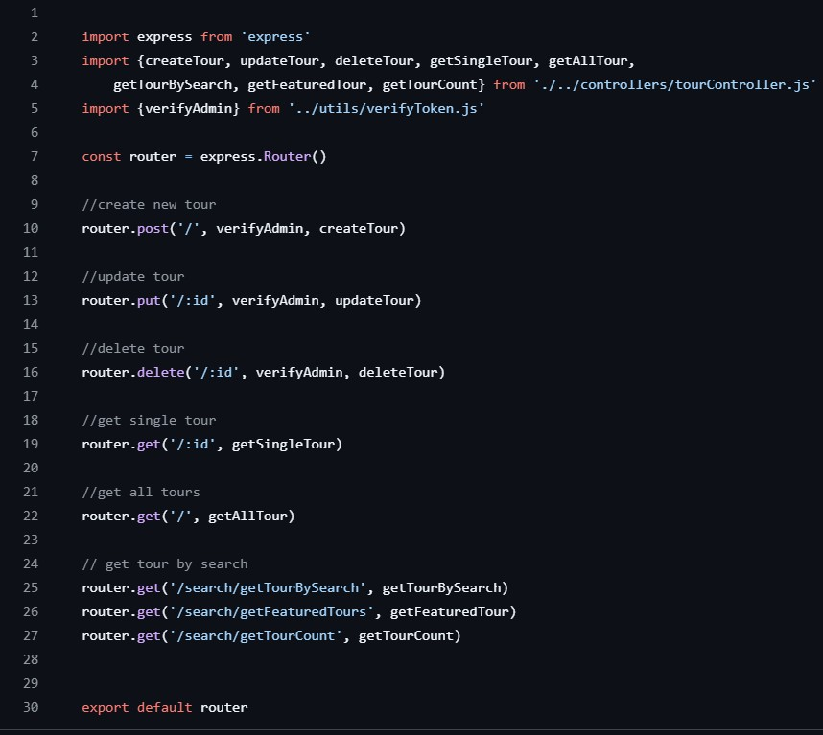

**6.TESTING APPROACH (Travel and Tour with AI)**

To make sure the Travel and Tour with AI app works properly, we followed a full and careful testing process. Testing means checking the app step-by-step to find and fix problems before giving it to real users. This helped us build a system that is smart, safe, and easy to use.

We used different types of testing during the development. Below is the simple explanation of each test we used.

1. **Unit Testing (Testing Small Pieces)**

**What it means:**

We tested each small part of the app, one by one. For example, we checked if the tour suggestion logic works correctly and if the system understands what the user wants**.**

**What we tested:**

* + The part of the app that gives destination suggestions using AI.
  + The login and registration process.
  + Small helper tools like checking travel distance or budget limits.
  + Checking user input (for example, if someone enters wrong dates or empty details).

**Why it’s important:**

This helps us catch small errors early, before they become big problems.

1. **Integration Testing (Testing Parts Together)**

**What it means:**

After testing the small parts, we tested how those parts work together. This includes AI, the web pages, the database, and other services like weather info or maps**. What we tested:**

* + A user enters travel details → AI gives suggestions → User books a tour.
  + Saving bookings and showing them in user history.
  + Connecting the chatbot with the travel database.
  + Showing correct information (like prices and places) from the server.

**Why it’s important:**

This makes sure everything is connected and works smoothly without errors.

1. **System Testing (Testing the Whole App)**

**What it means:**

We tested the app like a real user, from start to end. This helps us find issues in the full journey, not just in single parts**.**

**What we tested:**

* + Can a user search for tours easily?
  + Is booking a tour simple and clear?
  + Can a user go back and forth between pages easily?
  + Are confirmations and messages shown at the right time?

**Why it’s important:**

This shows us if the full system works the way we designed it and gives a smooth experience.

1. **User Acceptance Testing (Testing by Real People)**

**What it means:**

We gave the app to a group of people (like classmates, teachers, or friends) to use. They tested it like real users and gave us feedback. **What they did:**

* + Searched for places to visit.
  + Talked to the AI chatbot for help.
  + Booked a tour and saw the confirmation.
  + Checked their profile and travel history.
  + Logged in and out, and used the app like a traveller.

**What we learned:**

We got feedback like:

* + "This part is hard to understand."
  + "The chatbot is helpful, but slow in one place."
  + "The home page can be simpler."

**We made small changes to fix those issues and improve the app.**

1. **Performance and Compatibility Testing**

**What it means:**

We checked if the app runs fast and works well on all devices and web browsers.

**What we tested:**

* + Used the app on phones, tablets, and computers.
  + Checked if the screen size adjusts properly.
  + Used browsers like Chrome, Firefox, and Edge.
  + Measured how fast pages load and how quickly the AI gives suggestions.

**Why it’s important:**

People use different phones and browsers. We made sure the app looks good and works well for everyone.

1. **Security Testing (Keeping Data Safe)**

**What it means:**

We checked if user information like email, password, travel history, and payment details are kept safe.

**What we tested:**

* + No one else can log into someone’s account.
  + Personal data is not shown to others.
  + Booking and payment processes are secure.

**Why it’s important:**

Travel apps deal with personal and sensitive info. We want to keep users’ trust and protect their data.

1. **Regression Testing (Rechecking Old Features)**

**What it means:**

Whenever we added a new feature (like a new chatbot reply or new travel filter), we checked if the old features still worked.

**Why it’s important:**

Sometimes new updates break older parts. This helps us avoid that.

**Summary**

Testing is one of the most important parts of making a software product. For the Travel and Tour with AI application, we followed a strong and careful testing plan. Here's what we achieved:

* + Each small part works properly.
  + All parts work well together.
  + The full app is easy and smooth to use.
  + Real users tested it and gave helpful feedback.
  + The app is fast, looks good, and works everywhere.
  + Data is protected and safe.
  + New updates didn’t break old features.

With this testing approach, we made sure the app is ready for real users, reliable, smart, and helpful for planning trips using AI.

**6.2.2 Integration Testing (Travel and Tour with AI)**

Integration testing checks if all the different parts of the app work properly together. After testing small parts separately (called unit testing), we now test how the system works as a whole — how the frontend (what the user sees), the backend (server logic), the database (where data is stored), and the AI assistant connect and talk to each other.

In the *Travel and Tour with AI* project, this was very important. We needed to see if the user actions (like searching for a tour or booking a trip) work smoothly through the whole system.

**Key Integration Scenarios**

* + **User Registration and Login:**

When a user signs up, their details are sent from the frontend to the backend, and stored in the database. We tested that the whole flow works without any issue and that the login system protects users using tokens.

* + **Tour Search and AI Suggestions:**

The user enters preferences like location, budget, or travel dates. These go to the AI engine, which gives suggestions. We tested if the suggestions were correct and shown quickly on the screen.

* + **Tour Booking:**

After choosing a tour, the user clicks “Book.” We checked that the booking request is processed correctly and stored in the database.

* + **Chatbot Conversations:**

We tested the chatbot that helps users with travel questions. It had to connect with the backend and database to answer correctly**.**

* + **Admin Functions:**

Admins can add, update, or delete tour packages. We tested that these actions work and the changes appear for users instantly.

**Tools and Methods Used**

* + **Postman:**

We used Postman to check backend APIs — like fake user signups, tour bookings, or search queries — to see if everything responds correctly.

**Browser Tools (Console & Network tab):**

These helped us watch how data moves when someone uses the site.

* + **MongoDB Compass:**

We used this to see if data was stored correctly in the database — like checking if bookings were saved properly.

**Benefits of Integration Testing**

* + Helped find problems that only happen when all parts work together.
  + Proved that data is flowing correctly from user to AI and back.
  + Made sure full user journeys — from search to booking — work well.
  + Helped confirm chatbot replies and tour suggestions are accurate.
  + Increased our confidence in the app’s overall performance.

**System Testing**

This testing looks at the app as a complete system. We acted like real users and tested everything from start to finish.

**What we tested:**

* + Search and tour suggestions from the AI
  + Selecting and booking a tour
  + Logging in and viewing user profile and travel history
  + Admin tasks like managing tour data
  + Moving between pages and checking layout
  + Error messages for wrong or missing inputs

**User Acceptance Testing (UAT)**

We asked real users — like friends, classmates, or teachers — to use the app and give feedback.

**Users tried:**

* + Searching for travel destinations

Using the chatbot to get help or ideas

* + Booking a tour
  + Viewing past bookings
  + Exploring different sections of the app **What we learned from their feedback:**
  + Some buttons needed better placement
  + Users wanted faster chatbot responses
  + Search filters needed clearer labels

**We improved these areas to make the app easier for everyone.**

Performance and Compatibility Testing

We also tested how well the app works on different devices and browsers**.**

**What we checked:**

* + App works smoothly on phones, tablets, and computers
  + Tested on Chrome, Firefox, and Edge browsers
  + Load time and screen transitions are fast
  + Chatbot and AI suggestions work without slowing down

**Summary**

Testing helped make the *Travel and Tour with AI* app strong, smooth, and easy to use. We tested everything from small functions to full user journeys. The result is an app that’s ready to be used in the real world.

**Key Points**

* + All major features (search, booking, chatbot, admin) were tested and work well
  + Frontend and backend communicate using APIs
  + Secure login and data protection with JWT tokens
  + The AI assistant gives correct suggestions based on user input
  + MongoDB handles all bookings and user data

We used tools like Postman and MongoDB Compass for testing

* + The app works on all devices and passed every test
  + It’s now fully ready to be used by users and travel businesses

# 7. RESULTS AND DISCUSSION

This chapter shows what we achieved after building and testing the Travel and Tour with AI application. Every feature was created according to the planned requirements and tested to see if it works correctly. Below are the main features, with explanations and screenshots (if added), showing how they work and why they are useful.

**7.1 USER REGISTRATION AND LOGIN**

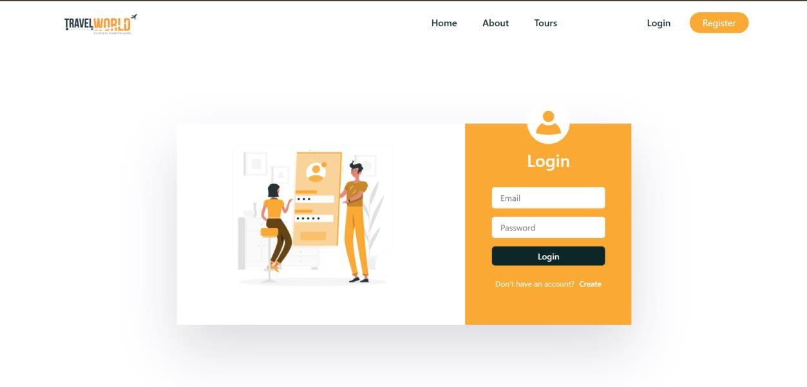

1. User Registration and Login

The user can easily register by entering basic details like name, email, and password. After registration, the user can log in and access the full system.

Result: Secure login using token-based authentication.

Why it matters: Keeps user data safe and allows personalized travel planning.

**Functionality:**

Allows users to create a new account and log in securely

**Result:**

* + - New users can register using their email and password.
    - Passwords are stored securely using encryption.
    - Existing users can log in using correct credentials.
    - After logging in, users are taken to their dashboard for travel planning.

**Screenshot Placeholder:**

*User Registration/Login Form*

**7.2 DASHBOARD AND SERVICE NAVIGATION**

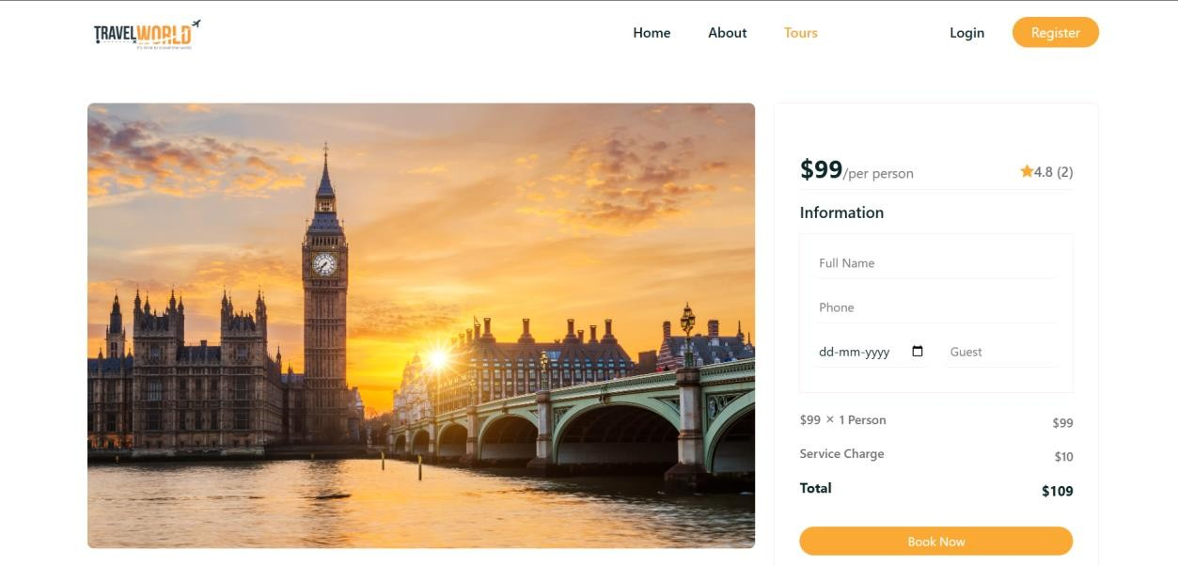

**Functionality:**

This section of the application helps users easily explore tour packages, view trip details, and book services.

**Result:**

* + - The dashboard displays a featured destination with a clear image and price.
    - Users can view important information like trip cost, service charges, and total amount.
    - A form allows users to enter their name, phone number, date of travel, and number of guests.
    - A clear “Book Now” button is provided to confirm the booking.
    - The layout is clean, visually appealing, and user-friendly.
    - Key options like **Home**, **About**, **Tours**, **Login**, and **Register** are visible on the top menu for easy navigation.

**Screenshot Placeholder:**

*Dashboard View with Booking Panel and Navigation Menu*

**7.3 TRAVEL PLACE BROWSING:**

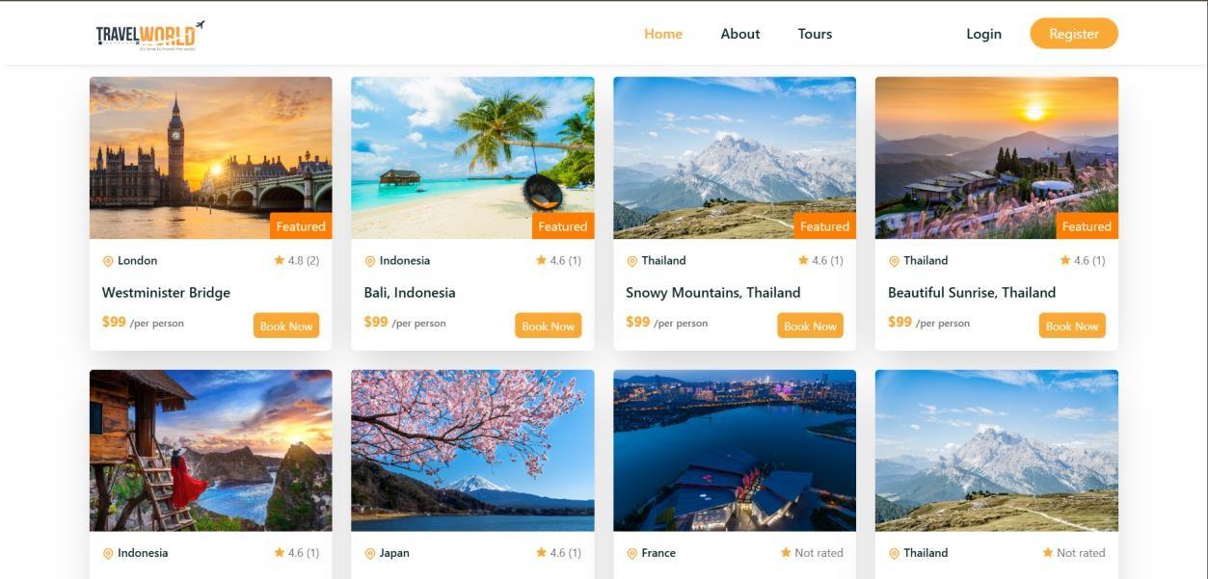

**Each Destination Card Includes:**

**1. Image of the Destination:**

oVisually appealing photos help users quickly recognize and feel attracted to a place. oExample: Westminster Bridge (London), Bali (Indonesia), Snowy Mountains (Thailand), etc.

1. **Location Information:** 
   * + - Each card displays the country and specific place (e.g., "Thailand - Snowy Mountains").
       - An icon ( ) helps highlight the location easily.
2. **Ratings:** 
   * + - Ratings are shown using stars ( ). oSome have user reviews in parentheses, e.g., 4.8 (2).
       - Places with no reviews are labelled "Not rated".
3. **Price:** 
   * + - Uniform pricing is shown: $99 per person.
       - Helps users quickly compare value.
4. **Action Button:**

oA clear "Book Now" button encourages immediate action and booking.

1. **Badges (Optional):**

oSome destinations are marked "Featured", suggesting special promotions or popularity.

**Top Navigation:**

* Home, About, Tours, Login, Register options are visible at the top.
* The Register button is highlighted in orange to draw attention.

**User Benefits of This Browsing Layout:**

* **Easy Comparison:** Users can compare multiple locations side-byside.
* **Quick Decision-Making:** Visuals + key info (rating, price, location) allow faster choices.
* **User Engagement**: Attractive UI with strong CTAs (Call To Actions) like “Book Now.”

**7.4 TRAVELL BOOKING:**

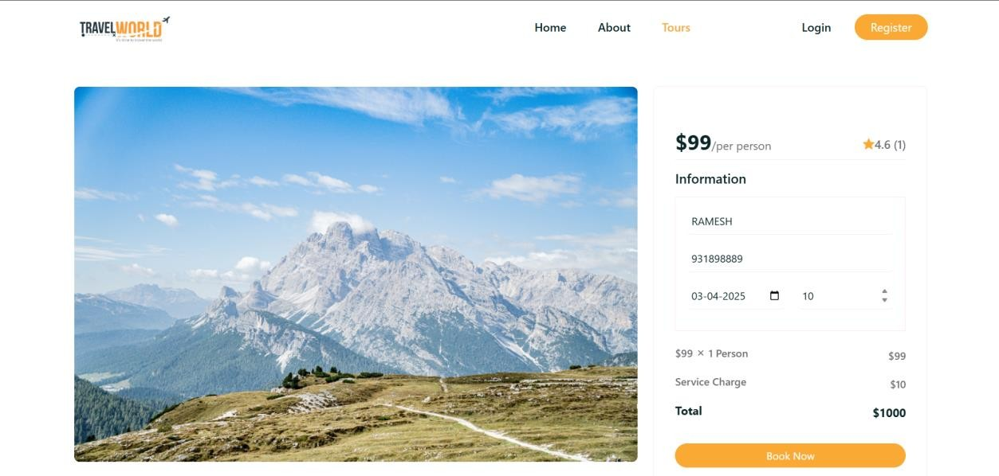



**Visual Layout Overview:**

* Left Side: A large, attractive photo of the selected travel destination (e.g., mountain landscape).
* Right Side: A booking panel with pricing, form fields, and total calculation.

**Booking Details:**

1. Price Information:
   * Base price: $99 per person oDisplayed clearly at the top right for quick visibility.
2. User Rating:
   * Rating shown as 4.6 (1) with a star icon, indicating the quality of the experience based on reviews.
3. Customer Information Form:
   * Name: e.g., RAMESH o Contact Number: e.g., 931898889 o Date Selection: e.g., 03-04-2025 o Number of Persons: e.g., 10
4. Pricing Breakdown:
   * Travel: $99 x 1 Person = $99 o Service Charge: $10 oTotal: $1000 *(Note: The total reflects 10 people including the service charge.)*
5. Action Button:
   * A clear orange “Book Now” button finalizes the booking.

## HOME

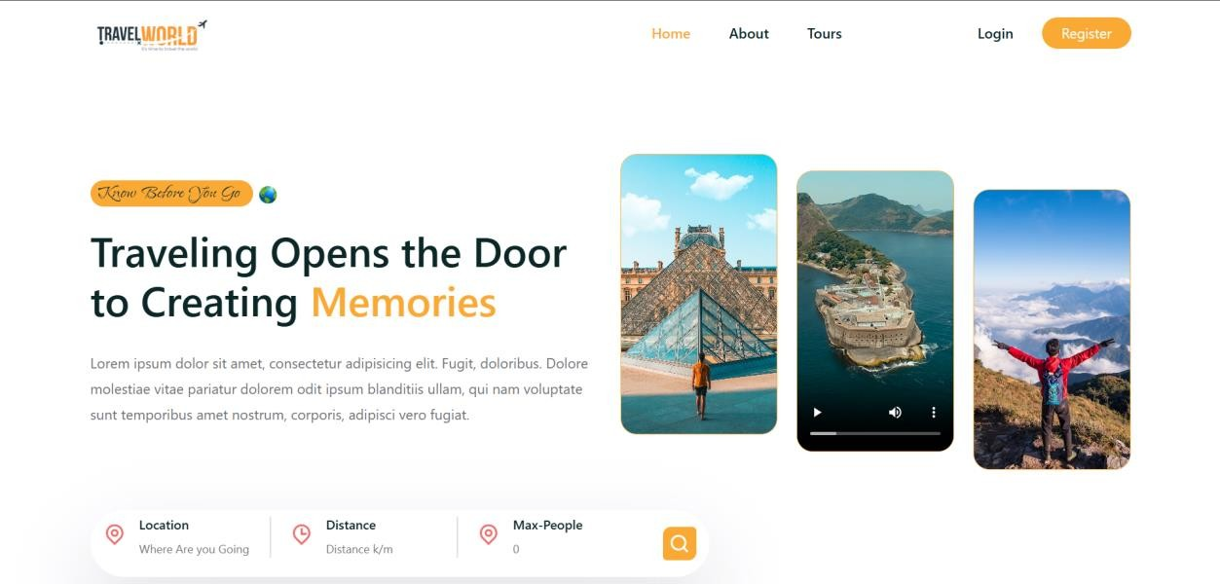

**ABOUT**

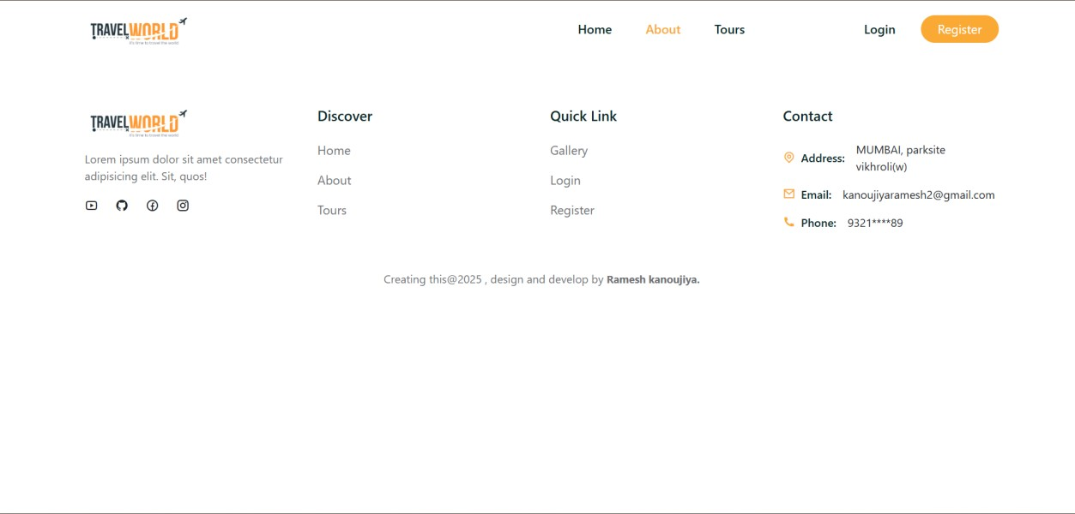

**TOUR**

**PAGE 1**

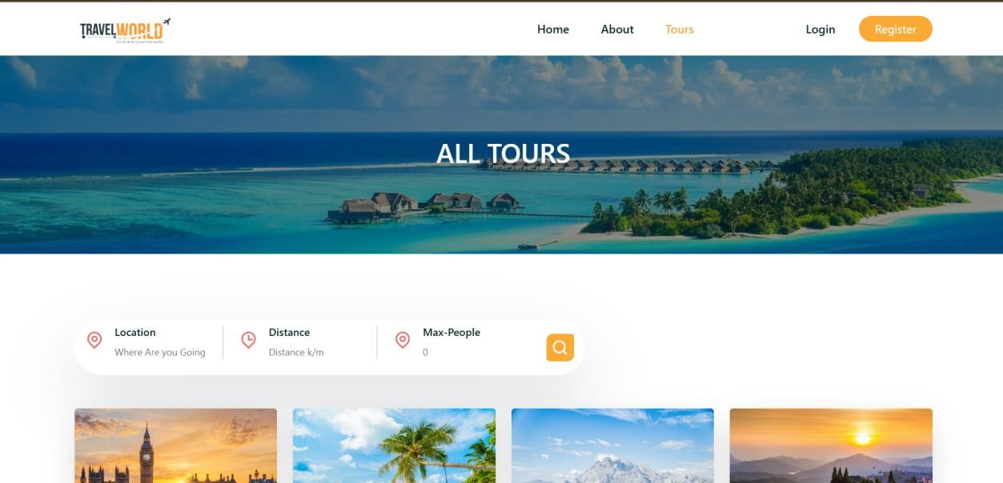

**PAGE 2**

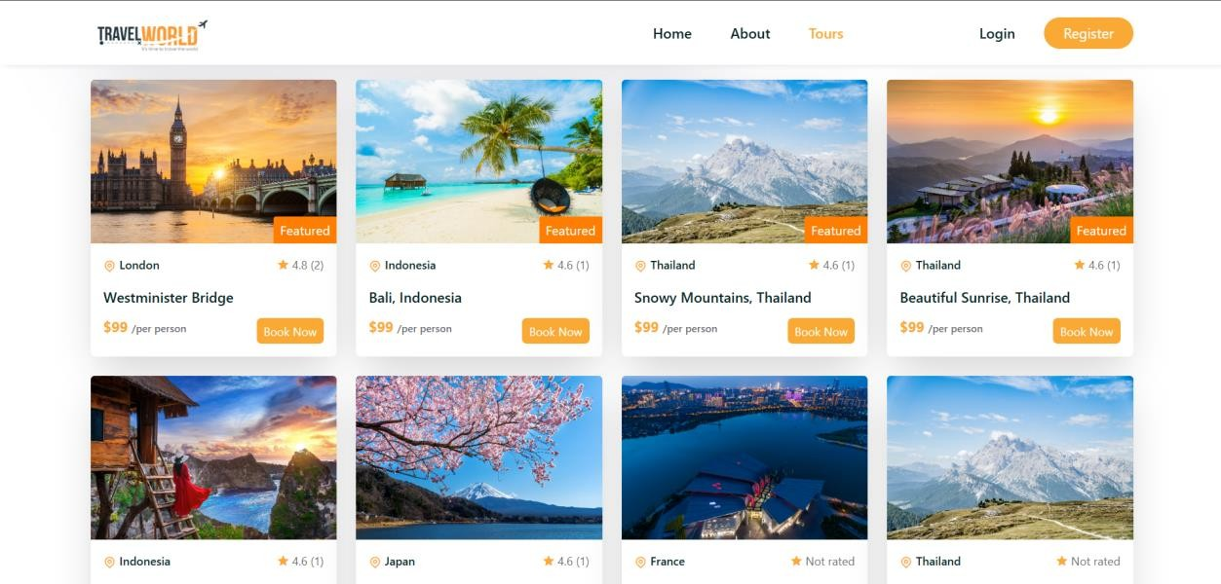

**PAGE 3**

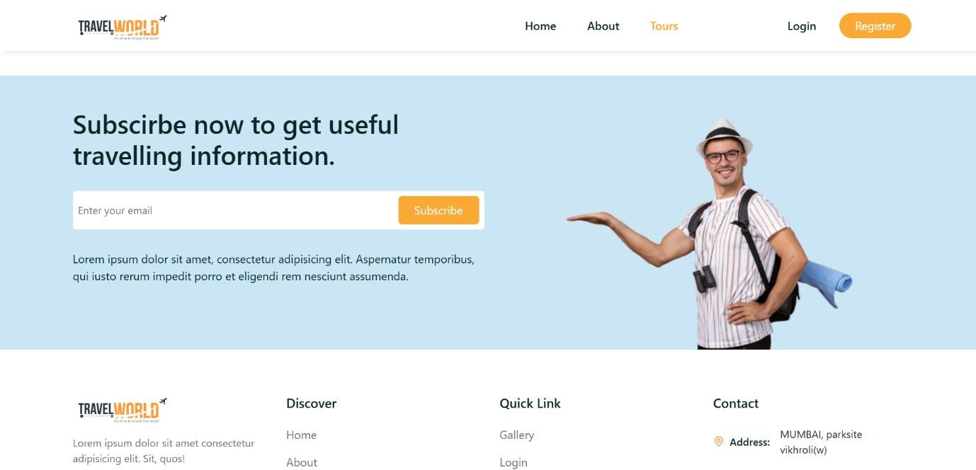

**REGISTRATION:**

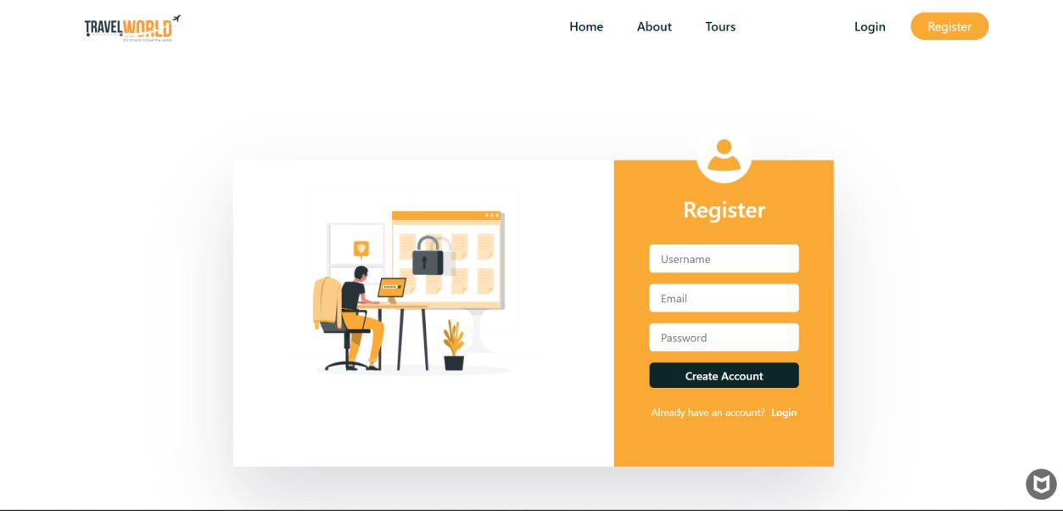

**DISCUSSION**

Here’s a customized version of your provided text, rewritten to suit your Travel and Tour with AI-based Project. This explanation reflects system testing, performance, and readiness for real-world use—ideal for a black book or academic submission:

**System Testing and Evaluation – Travel and Tour with AI**

The Travel and Tour with AI system was thoroughly tested to ensure its functionality, performance, and security met real-world standards. The testing included both automated test cases and real-user interaction analysis. Below are the key outcomes and insights observed during the evaluation phase:

**Functional Accuracy**

All core features such as destination browsing, tour booking, user authentication, and AI-based travel suggestions performed exactly as intended. There were no unexpected behaviors across different functional scenarios.

**Real-Time Responsiveness**

The system delivered quick response times during actions like searching for destinations, viewing tour details, and booking confirmations. The integration of APIs enabled real-time processing, ensuring users received instant feedback for their interactions.

**Frontend Performance**

Built using React, the frontend offered a fast, interactive experience.

Smooth transitions between pages, instant updates of AI-based suggestions, and responsive layouts made the interface user-friendly and efficient on both desktop and mobile devices.

**Backend Stability**

The backend, developed using Node.js and Express.js, was stable and efficient. It handled user inputs, booking data, and AI requests with no downtime or major errors, ensuring continuous service during testing.

**Database Reliability**

Using MongoDB, the system reliably stored large volumes of travel data, including user profiles, booking histories, destination details, and reviews. Data retrieval during search and booking was quick and accurate.

**Security Handling**

Security was a major focus. The system used JWT tokens for secure user sessions and bcrypt hashing for password protection. Role-based access (User/Admin) ensured proper control over sensitive functionalities**.**

**Scalability**

The system architecture was modular and scalable. With a decoupled frontend and backend using RESTful APIs, additional services like hotel integration, flight search, or AI trip planners can be added without disturbing core modules.

**User Experience**

Feedback from test users confirmed a positive and intuitive user experience. The interface was easy to navigate, with clear booking steps, helpful AI recommendations, and visually appealing destination displays.

**Conclusion**

The Travel and Tour with AI system has proven to be functionally accurate, secure, scalable, and user-centric. Testing helped identify issues early, ensure code quality, and confirm that the system is ready for real-world deployment.

**Summary**

Testing was crucial to validate the Travel and Tour with AI system. A layered testing approach ensured a reliable and bug-free experience, making the final product robust, efficient, and prepared for future enhancements.

**8.CONCLUSION**

**8.1 Project Achievement and Conclusion – Travel and Tour with AI**

The Travel and Tour with AI project has successfully delivered an innovative platform that combines traditional travel browsing with AI-powered recommendations and seamless tour booking. Built using the MERN stack (MongoDB, Express.js, React.js, Node.js), the system emphasizes simplicity, functionality, and accessibility for travellers.

One of the key achievements of this project is its ability to cater to diverse traveller needs — from those seeking popular tourist spots to users wanting personalized trip suggestions based on their preferences. This AI-integrated solution not only streamlines the travel planning process but also eliminates the need for using multiple apps or websites for recommendations, bookings, and information.

From a technical perspective, the entire stack works in harmony to deliver real-time data flow, fast navigation, and a user-centric interface. Secure authentication and modular APIs contribute to system reliability and allow easy updates in the future. Whether it's booking a scenic destination or exploring travel tips generated by AI, users can interact with the system smoothly across devices.

The system has been tested for various input scenarios and performs reliably. Modular components in both the frontend and backend ensure clean code structure, easier maintenance, and scalability for advanced features. This project is a prime example of combining full-stack web technologies with AI capabilities in a real-world travel application.

With additional improvements, the platform can be enhanced further into a commercial-grade travel assistant, offering value to travel companies, tourism departments, or individual users.

**6.2 Limitations of the System**

While the Travel and Tour with AI system is functional and efficient, a few limitations exist in its current form, which may impact the full user experience or restrict broader scalability:

* No Live Booking Sync with Vendors: Currently, bookings are stored in the system database, but integration with real hotel/transport APIs is not yet implemented.
* No Payment Gateway Integration: All bookings are processed as mock transactions. Real-time payment options are not yet integrated.
* Limited AI Functionality: The AI currently provides general travel suggestions. Advanced features like itinerary generation or seasonal analysis are not yet included.
* Basic Filtering Options: Search filters are limited to location and ratings. Advanced filters (e.g., by activity type, travel time, or group size) are yet to be implemented.
* No Multilingual Support: The platform only supports English, which may limit adoption among non-English speaking users.
* No Native Mobile App: Although the web platform is responsive, a dedicated mobile app would provide a better experience, especially for travellers on the move.
* Limited User Roles: Currently, only "Admin" and "User" roles are supported, with no tiered or agency-level user management.

These limitations do not hinder the core purpose of the platform but highlight areas for improvement in future updates to enhance the overall experience**.**

**9. Future Scope of the Project**

This project has been designed with future scalability in mind. Various improvements and advanced features can transform the system into a comprehensive AI-powered travel solution. Future development may include:

* Payment Integration: Real-time transaction support through credit/debit cards, UPI, and wallets for secure bookings.
* Live API Integration with Travel Partners: Collaborations with hotel chains, travel agents, and transport services to sync bookings in real-time.
* Smart Itinerary Planner: Using AI to generate personalized itineraries based on duration, interests, and past travel behaviour.
* User Feedback and Ratings: A review system to help users make informed decisions and improve service quality.
* Voice-Assisted Navigation: Integrating voice assistants for actions like “Show top destinations” or “Read travel tips” to improve accessibility.
* Multilingual Interface: Adding regional languages will increase inclusivity for a broader audience.
* Mobile App for Android and iOS: Offering a native mobile version for seamless access and offline support.
* Chatbot for Travel Queries: An AI-powered chatbot can assist users with FAQs, booking support, and destination recommendations.
* Weather and Travel Alerts: Real-time updates for weather, flight changes, or local restrictions can help users plan better.
* Dark Mode and Accessibility Tools: Enhancing UI for visually impaired users and improving the overall interface appeal.

These enhancements would make the platform highly adaptable, commercially viable, and capable of delivering a superior user experience.

**10.** **Bibliography**

* 1.Smith, John. *Introduction to Tourism Management*. Oxford University Press, 2020.
* 2.Gupta, R.K. *Travel and Hospitality in India*. McGraw Hill, 2018.

**11.REFERENCES**

1.Firebase. (2025). Firebase Documentation. Retrieved from

<https://firebase.google.com/docs>

1. Mozilla Developer Network (MDN). (2025). HTML, CSS, and JavaScript

Documentation. Retrieved from [https://developer.mozilla.org](https://developer.mozilla.org/)

1. W3Schools. (2025). Web Development Tutorials and References.

Retrieved from [https://www.w3schools.com](https://www.w3schools.com/)

1. ISO/IEC/IEEE 29119-1:2013. (2013). Software and systems engineering — Software testing — Part 1: Concepts and definitions. International Organization for Standardization.

1. Sommerville, I. (2015). Software Engineering (10th ed.). Pearson Education.
2. GeekforGeeks. (2025). Software Testing Techniques and Strategies.

Retrieved from <https://www.geeksforgeeks.org/software-testing-basics/>

1. Stack Overflow. (2025). Firebase Real-time Database Integration Queries and Solutions. Retrieved from https://stackoverflow.com/ 66

1. Bootstrap. (2025). Bootstrap Framework Documentation. Retrieved from https://getbootstrap.com/docs
2. Patel, D. (2022). Practical Web Development using HTML, CSS, JavaScript, and Firebase. DreamTech Press.
3. Google Developers. (2025). Firebase Authentication Overview. Retrieved from https://firebase.google.com/products/auth

# 11.Tools, and Learning Resources

This section lists all the essential tools, references, and learning materials that were utilized during the development of the Apna-Kitchen-Recipes project. These resources supported various stages including backend, frontend, database management, testing, deployment, and documentation.

**11.1 Development Tools and Frameworks**

* **MongoDB Documentation –** [**https://www.mongodb.com/docs/**](https://www.mongodb.com/docs/)

Used to understand document structures, schema design, and query handling.

* **React.js Official Docs –** [**https://reactjs.org/docs/getting-started.html**](https://reactjs.org/docs/getting-started.html) Helped in building reusable components and implementing state management.
* **Node.js Official Site –** [**https://nodejs.org/en/**](https://nodejs.org/en/)

Provided backend setup guides and JavaScript runtime references.

* **Express.js Guide –** [**https://expressjs.com/en/starter/installing.html**](https://expressjs.com/en/starter/installing.html) Assisted in creating RESTful APIs and implementing middleware**.**
* **Visual Studio Code –** [**https://code.visualstudio.com/**](https://code.visualstudio.com/)

Used as the primary code editor for both frontend and backend development**.**

**11.2 Authentication and Security**

* **JWT (JSON Web Token)**

Enabled secure, stateless user authentication by encoding user details in signed tokens passed between client and server.

* **bcrypt.js**

Used for password hashing to enhance credential security with salting and hashing algorithms.

**These technologies together ensured secure access to protected routes, safeguarded user data, and maintained integrity during login and registration.**

**11.3 UI and Testing Tools**

* **Bootstrap**

Used for responsive design with pre-built UI components and mobile-first layout structure**.**

* **Postman**

Aided in REST API testing with support for all HTTP methods, response tracking, and collection-based test cases.

* **Chrome Developer Tools**

Enabled real-time debugging, frontend inspection, and performance optimization during development**.**

**11.4 Project Management and Hosting**

* **Git & GitHub**

Provided version control, team collaboration features, branching strategy (Gitlow), and code reviews.

* **Netlify (Frontend Hosting)**

Hosted the React frontend with continuous deployment and HTTPS integration.

* **Render (Backend Hosting)**

Deployed the Node.js/Express server securely, with automatic build and Git integration.

* **MongoDB Atlas**

Offered cloud-based MongoDB storage with real-time monitoring, IP whitelisting, and secure data handling**.**

**11.5 Academic and Learning Resources**

* **Books & Literature:** 
  + - *Modern Systems Analysis and Design* – Provided SDLC and system planning frameworks.
    - *Cite Right* – Ensured proper academic referencing and documentation formatting**.**
* **Online Learning Platforms:** 
  + - FreeCodeCamp – MERN tutorials and coding projects.
    - GeeksforGeeks – Database, algorithms, and backend topics.
    - TutorialsPoint – Structured MERN stack guide.
    - W3Schools – Syntax and basic reference for HTML/CSS/JS.
* **Video Tutorials and MOOCs:** 
  + - YouTube Channels – (Traversy Media, Net Ninja, Academind) for visual learning.
    - Coursera & edX – Learned cloud deployment and full-stack architecture fundamentals.
* **Community Forums & Documentation:** o Stack Overflow – Solved code errors and explored best practices.

o Official Docs – MERN stack technology references for implementation.

**11.6 Standards and Guidelines Followed**

* **ISO/IEC 12207 –** Adopted SDLC practices including requirement gathering, implementation, and testing.
* **IEEE 1063 –** Ensured quality user documentation with logical structure and readability.
* **ISO/IEC 25010 –** Focused on software quality attributes like usability, reliability, and maintainability.
* **OWASP Secure Coding Guidelines** – Applied secure authentication (JWT), password hashing (bcrypt), input sanitization, and CORS policies**.**
* **GitFlow Workflow** – Followed structured version control with feature and release branches.

**This robust collection of tools, standards, and learning sources ensured that the Apna-Kitchen-Recipes project was developed using industry-best practices, resulting in a scalable, secure, and professional-grade full-stack web application.**